📌 Simple Linear Regression from Scratch

This project demonstrates how to implement \*Simple Linear Regression\* from scratch using NumPy and visualize it using Matplotlib. It's built using a Jupyter Notebook.

---

🔧 Features

- Generate synthetic dataset

- Calculate slope and intercept manually

- Visualize the regression line

- Evaluate the model with R² Score

---

🧠 Concepts Covered

- Linear Regression Formula

- Mean Calculation

- R² Score (Goodness of Fit)

- Data Visualization with Matplotlib

---

📁 Files

- `Linear Regression.ipynb`: Main Jupyter Notebook with the code

- `README.md`: Project documentation

---

📊 Output Sample

- Plots: 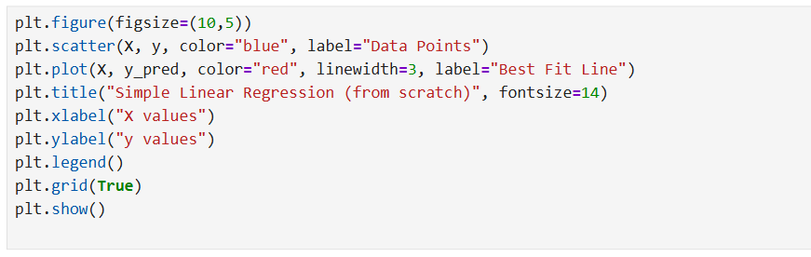

- Scatter plot with the regression line:

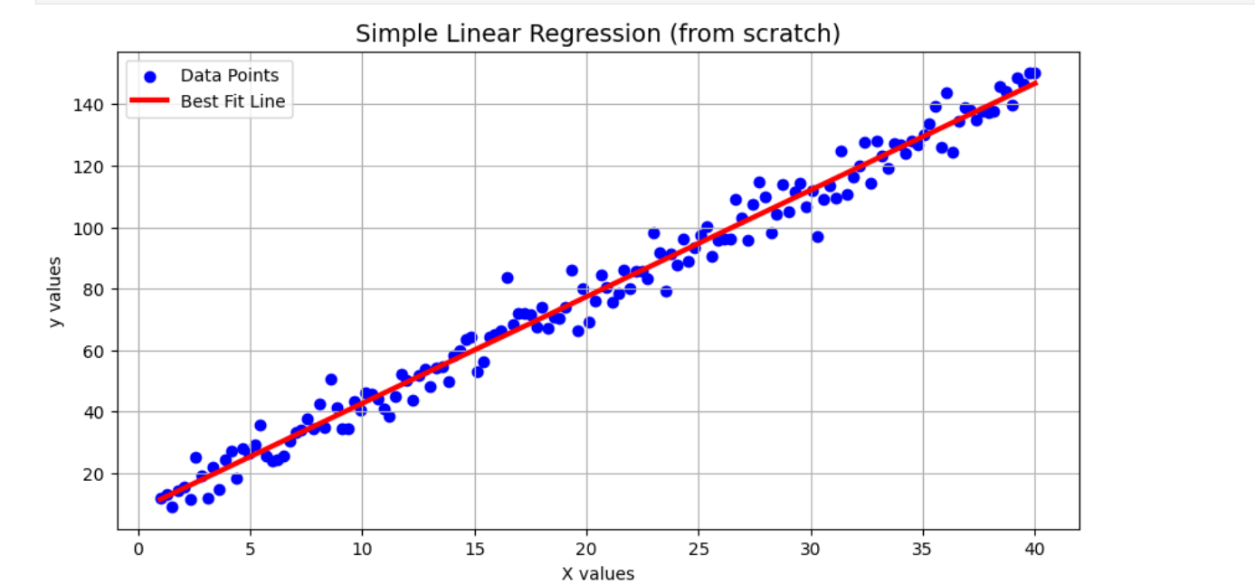

- R² score :



---

📌 How to Run

1. Clone the repository

2. Open `Linear Regression.ipynb` in Jupyter Notebook

3. Run the cells to see the output

---

🧑‍💻 Author

Made with ❤ by [MANOJRAJ G]

---